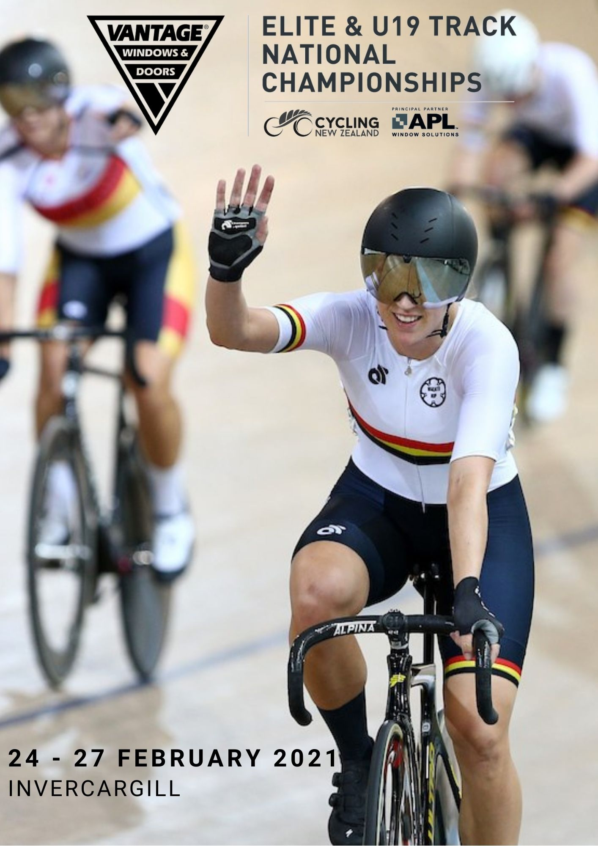

- WELCOME

On behalf of the Cycling New Zealand Road and Track Council, I offer you all a warm welcome to the 2021 Vantage Elite and U19 Track National Championship, here in Invercargill.
After a year that has seen many challenges for travel, gatherings, economies, and holding sporting events, it will be exciting to have another opportunity to see New Zealand's top track cyclists racing for the coveted National Champion jersey on the boards of the SIT Zero Fees Velodrome.
Thanks to the event organisers and to the team of volunteers, officials, and our Commissaires, all of whom are giving up their time to ensure the event happens. We are grateful for the support of the people here this weekend but also to the hundreds of volunteers who work tirelessly behind the scene at club events around the country. Volunteers are truly the backbone of cycling in this country.
We wish all the riders the best of luck and a safe and successful competition and to the spectators we hope you enjoy exciting racing.
Mike Sim
President, Cycling New Zealand Road and Track

On behalf of Cycling New Zealand, our board and sponsors, we welcome you all to Invercargill for the Vantage Elite Track National Championships.
This event is the premier event on the domestic track cycling calendar and it’s great to see so many of our top cyclists representing centres.
We acknowledge the part that the coaches, managers and other support staff will play in assisting the riders this week and thank them for their time and commitment to the sport.
We thank Cycling Southland for hosting the event at the SIT Zero Fees Velodrome, and our valued partner; Vantage Windows & Doors for their support.
Special thanks to the volunteers and the Cycling New Zealand Commissaires who play a fundamental role in supporting the integrity of our sport and ensure safe and fair racing.
To all the riders – we wish you all the best for the upcoming days as we all look forward to watching the exciting racing!
Jacques Landry
CEO, Cycling New Zealand

- KEY CONTACTS

Event Manager Steff Jordaan 027 855 7676
Chief Commissaire Stephen Holdsworth
Technical Delegate/ Judge Referee Erin Criglington
Commissaire's Secretary Shannon Rafferty
Chief Judge / Timekeeper Mark Reynolds
Starter Ian Densie
Assistant Commissaires Brian Roulston
Graeme Bell
Neil Jamieson
Paul Tomlinson
Steve Hurring
Tony Corkill
Waine Harding

- VENUE ACCESS/ACCREDITATION

The Velodrome will be open for competition access from 8am each morning. The venue will close 30 minutes after the end of the night session. In between sessions you are welcome to remain in the infield however the use of the track is prohibited until the official warm up period begins.

Date | Morning Session Start | Evening Session Start
Wednesday 24 February | 10.00am (track opens at 9.00am) | 5.00pm (track opens at 4.00pm)
Thursday 25 February | 10.00am (track opens at 9.00am) | 5.00pm (track opens at 4.00pm)
Friday 26 February | 10.00am (track opens at 9.00am) | 5.00pm (track opens at 4.00pm)
Saturday 27 February | 10.00am (track opens at 9.00am) | 5.00pm (track opens at 4.00pm)

Accreditation Passes are for riders and team officials only – as per named persons on the entry form. Accreditation must not be passed onto unnamed persons. Additional supporters, family and friends are required to purchase event tickets and view the event from the public areas. Entry and exit for accredited riders and officials is through the tunnel entrance of the building or via the front entrance. Access to the infield will be controlled and access will only be permitted for accredited persons only. Please ensure your accreditation is clearly visible when you are entering the venue. All team accreditation passes will be issued at Confirmation of Starters. Please do not put our volunteer staff in the position of refusing entry to guests who do not have accreditation, invalid accreditation or event tickets.

- EVENT PROGRAMME

The provisional event programme is available here. Note that the programme is provisional and is subject to change after confirmation of starters.

- TEAM TRAINING

Centres can book one or two hour slots of training time for Tuesday 23 February. Charges apply. Contact Cycling New Zealand Events Team by emailing events@cyclingnewzealand.nz to book track time. To book training time prior to Tuesday 23 February, please contact Cycling Southland by emailing office@cyclingsouth.org.nz

- WARM UP SESSION TIMES
The track will be open for warmup one hour prior to the event programme commencing each session. The warm up session will be approximately 50mins prior to the beginning of each session. Approximately 10mins prior to the scheduled session start time, a Commissaire will blow a whistle for the riders to exit the track. Please adhere to the instructions of the Commissaires at all time.

- INFIELD GYM
Please note that the infield gym is closed to all event riders and officials during all event times. No access will be granted at any time.

- PARKING
Free parking is available in the venue carparks. The venue accepts no liability for any damage to any vehicles parked in or otherwise using the car parking area.

- TEAM MANAGERS MEETING & CONFIRMATION OF STARTERS

Confirmation of starters will be held on Tuesday 23rd February from 4.30pm – 5.15pm, following by the Team Managers Meeting at 5.30pm in the Champions Lounge at the SIT Zero Fees Velodrome. Please note that it will not be possible to add riders to events. Managers must confirm their starters at this point.

Attendance at the Team Managers Meeting by each centre is compulsory and representatives will be required to sign in.

Important information such as distribution of accreditation and race numbers and any updated programme information will be provided at this meeting. Accreditation is compulsory for access to the infield and will also allow you access to the public spectating areas. Accreditation does not automatically entitle you to a seat, however, if there are available seats, you are permitted to use these.

Confirmation of Starters
Date: Tuesday 23rd February
Time: 4.30pm – 5.15pm
Venue: SIT Zero Fees Velodrome.
Required: Yes – All Team Managers are required to confirm their starters during this time.

Team Managers Meeting
Date: Tuesday 23rd February
Time: 5.30pm – 6.00pm
Venue: SIT Zero Fees Velodrome.
Required: Yes – All Team Managers are required to attend.

Track Combining Symposium
Date: Tuesday 23rd February
Time: 6.00pm – 7.00pm (or immediately following the Team Managers Meeting)
Venue: SIT Zero Fees Velodrome.
Required: No – Any interested parties may attend

- RACE NUMBERS

Riders shall wear two body numbers except for the 500m & kilometre time trial, Individual & Team Pursuit & Team Sprint, where one number shall be worn.
Numbers must be placed on either side of the lower back of the top on a 90 degree angle as shown below.
Correct Number Placement
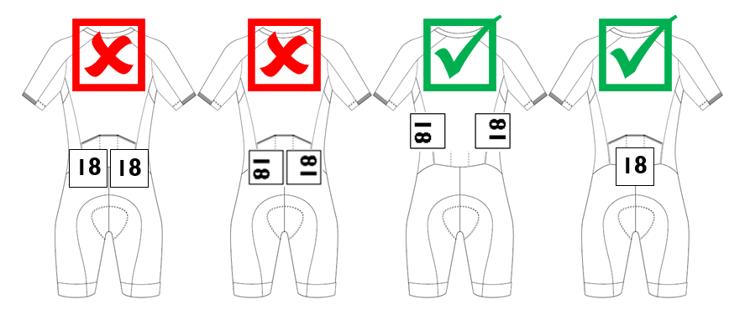
- TEAM PIT AREAS

Designated pit areas have been allocated in the infield for each centre. The pit includes chairs and tables. Please do not uplift furniture or equipment from other team pits. Bike Racks are available to be shared by all teams.

Please ensure the walkways are kept free of equipment to allow un-impeded access at all times.
There is to be no riding of bikes in the team pit areas.

- MEDICAL

Medical staff on are on duty during each session.
The following Medical Centres are on duty over the event period if medical assistance is required while not at the event.
Invercargill Medical Centre (weekdays only)
160 Don St, Invercargill
(03) 218 9116
Invercargill After Hours Doctors (from 6pm weekdays and 9am weekends)
105 Don St, Invercargill
(03) 218 8821
Southland Hospital
Kew Rd, Invercargill
(03) 218 1949
In an Emergency call 111

- FOOD AND BEVERAGE
Food and beverages will be available for purchase from the Handlebar Café during the evening sessions and from the Main Foyer Café during the day sessions.
The Handlebar café will be open from 4:30pm each day ready for the 5:00pm session start.
On the Wednesday and Thursday nights, the Handlebar Café will close at 9.00pm). On the Friday and Saturday nights the Handlebar Café will close at the start of the last race as per normal.

You are permitted to bring in your own food and beverage to the infield.

- TICKET SALES

Tickets for additional supporters, friends and family can be purchased at the venue. Seating is General Admission with no reserved seating. See www.elitetracknationals.nz for ticketing information.

- SOCIAL MEDIA

We encourage you to get involved in the event through social media. The key links are provided below:

Event Facebook | https://www.facebook.com/CyclingNZL
Instagram | https://www.instagram.com/cyclingnewzealand/
Twitter | https://twitter.com/CyclingNZL
Website | www.elitetracknationals.nz
Key Partners | @VantageWindowsNZ
Event Hashtag | #EliteTrack

- MEDAL CEREMONY PROTOCOL
Medal Ceremonies will take place during sessions as stated in the event programme.
Team Managers are responsible for ensuring their riders are at the presentation area at least 10mins prior to the presentation taking place. Medals winners must make themselves known to medal ceremony officials upon arrival. Due to the tight scheduling of the event programme a medal ceremony protocol has been established to keep these presentations streamlined.
- Riders will be lead to the podium by officials and the riders will stand in front of the podium (not on podium).
- Each rider will be acknowledged by name and representing centre.
- Riders receive their medal (and Trophy if applicable)
- Rider step onto podium.
- Once the 1st place has been presented a photo will be taken.
- Riders leave the podium and return to the waiting area lead by officials.
- Riders are required to leave their medal on until they return to the waiting area.
- All trophies presented are to be returned to Event Organisers before the end of the session.

- HEALTH AND SAFETY

The event has a Health and Safety plan which has taken into consideration the health and safety of the riders, team officials, volunteers, spectators and staff. Health and Safety is the responsibility of all those attending. If you have any concerns or identify any hazards please contact the Event Manager.

- RULES AND REGULATIONS

Racing will be conducted under UCI regulations and Cycling New Zealand Road & Track racing rules. The UCI scale of penalties will apply. Any fines issued are on the Team and are payable by the Team Manager to the Commissaires Secretary at the event or Centres will be invoiced post event.
Riders must only wear their approved Centre jerseys and shorts. Shorts may only display sponsors that are detailed on the rider’s membership profile.

- CHANGE FORMS

All Changes must be completed on the Change Request Form, as detailed below, and submitted to the Commissaires Secretary. Additional change forms will be available at the Team Manager’s meeting. Where applicable, a medical certificate should accompany the form.

Change Request Form
Centre | Rider No. | Rider Name | Event Name & No. | Change:  Eg. Scratching, addition, reserve, team confirmation, entry fee etc

Centre | Rider No. | Rider Name | Event Name & No. | Change:  Eg. Scratching, addition, reserve, team confirmation etc

Centre | Rider No. | Rider Name | Event Name & No. | Change:  Eg. Scratching, addition, reserve, team confirmation etc

Managers Name: ________________________________________
Managers Signature: ________________________________________
Date submitted: ________________________________________
Time submitted: ________________________________________
Change Accepted by: ________________________________________ (Chief Comm/Secretary)

