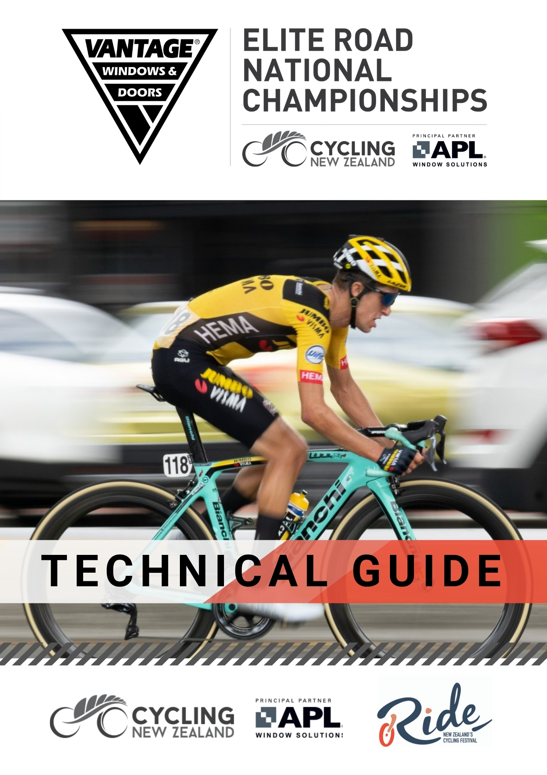
WELCOME
On behalf of the Cycling New Zealand Road and Track Council, I offer you all a warm welcome to the 2021 Vantage Road National Championships for Elite, U23 and now U19 riders, here in the Waikato.
After a year that has seen many challenges for travel, gatherings, economies, and holding sporting events, it will be exciting to have another opportunity to see New Zealand's top road cyclists racing for the coveted National Champion jersey on the scenic yet challenging roads around Cambridge.
Thanks to the event organisers, The Ride Festival for including this event in their festival. We also extend our thanks to the team of officials and our Commissaires, all of whom are volunteering their time to ensure the event happens. We are grateful for the support of the people here this weekend but also to the hundreds of volunteers who work tirelessly behind the scene at club events around the country. Volunteers are truly the backbone of cycling in this country.
We wish all the riders the best of luck and a safe and successful competition and to the spectators we hope you enjoy exciting racing.

Mike Sim
President, Cycling New Zealand Road and Track

On behalf of Cycling New Zealand, our board and sponsors, we welcome you all to Cambridge for the Vantage Elite Road National Championships.
This event is the premier event on the road cycling calendar and it’s great to see so many of our top cyclists representing their teams and Centres.
Last year we offered a change of date to accommodate many of our road cyclist who spend most of the season in Europe, this year the welcomed change is that U19’s will be added to the programme for the first time. Adding U19’s to this racing weekend means that even more national jerseys and titles will be contested.
We acknowledge the part that the coaches, managers and other support staff will play in assisting the riders this week and thank them for their time and commitment to the sport.
We thank Ride Festival for organising this event, and our valued partner; Vantage Windows & Doors for their support.
Special thanks to the volunteers and the Cycling New Zealand Commissaires who play a fundamental role in supporting the integrity of our sport and ensure safe and fair racing.
To all the riders – we wish you all the best for the upcoming days as we all look forward to watching the exciting racing!
Jacques Landry
CEO, Cycling New Zealand

KEY CONTACTS

Event Manager Nathan Cox 021 063 1777
Race Manager Stephen Cox 027 4925 672
Cycling New Zealand Events Manager Charlotte Pearson 021 292 0563
President of the Commissaires Panel Stephen Holdsworth 021 394 849
Assistant Chief Commissaire Erin Criglington
Technical Delegate Mark Ireland
Commissaire’s Secretary Olivia Spaans
Assistant Commissaire’s Secretary Graeme Bell
Chief Judge / Timekeeper Heather Smyth
Assistant Commissaires Zac Prendergast
Lisa Landers
Ray Sheath
Russell Mudgway
Mark Fleming
Steve Elden-Gray

EVENT PROGRAMME

Date | What | Location | Time
Thursday -  11th February | Confirmation of Starters | APL Building, 137 Swayne Rd - Cambridge | 5.00pm – 5.45pm
 | Team Managers Meeting | APL Building, 137 Swayne Rd - Cambridge | 6.00pm
Friday – 12th February | Vantage Elite & U19 Time Trial | Roto O Rangi School, Kairangi Road, Roto O Rangi | 10.00am
Sunday – 13th February | Vantage U19 Road Races | Tom Voyle Park, Taylor Street - Cambridge | 1.00pm Women  1.50pm Men
Sunday – 14th  February | Vantage Elite Road Races | Tom Voyle Park, Taylor Street - Cambridge | 8.00am Women  10.15am Men

EVENT SUPPORTERS

We would like to extend our thanks to the event supporters whom without their support the event would not be possible; naming partner, Vantage Windows & Doors and event organisers, The Ride Festival and their key sponsors including Grassroots Trust, Waipa District Council and Perry Modular Homes.

HEALTH AND SAFETY
The safety of the riders, officials, volunteer and spectators are included in the event planning. This includes (but is not limited to) traffic management and event advisories to the local businesses and residents. While the event has planned for likely scenarios, health and safety is everyone’s responsibility.

It is your responsibility to manage your own safety during the event, to be aware of other road users at all times and to make responsible decisions for yourself and those around you.

If you have any questions or concerns regarding Health and Safety please report to the Event Manager.

CONFIRMATION OF STARTERS AND REGISTRATION PACK PICK UP
This will be held on Thursday 11th February from 5.00pm – 5.45pm, at the APL Building, 137 Swayne Rd, Cambridge.
The team manager (or representative) only must confirm the identity of the riders who will be starting to the commissaires' panel. They shall then collect their Centre or Trade Team race packs. There will be no individual race number pick up permitted. The race pack will include all race numbers and timing transponders for their riders. It is the Team Managers (or representative) responsibility to distribute the individual race packs to their riders. Please note Team Managers are required to present a physical licence, a photo of the licence or proof of licencing for all their riders.
TEAM MANAGER’S MEETING
The Managers Meeting will be held on Thursday 11th February at 6.00pm, at the APL Building, 137 Swayne Rd, Cambridge. (Directions to meeting room can be obtained by asking at the information desk for the Ride Festival Criterium).
Each Centre or team with riders entered are required to nominate a Team Manager. Team Managers must hold a 2021 Cycling New Zealand Licence. Team Managers must be submitted either through the online system here, or by emailing events@cyclingnewzealand.nz with name, phone, email and licence number. Team Manager Details will be published on the website here. This Manager (or a representative thereof) must attend the Managers Meeting. All announcements regarding the racing will be given at this meeting, along with any amendments to the programme or procedures. The Team Manager is the point of contact between the event (including commissaires and race manager) and the riders. It is vital that the Team Manager passes on all information to riders and the wider team.
A sign in sheet will be in place to confirm team attendance at the Managers Meeting and a roll call will be conducted.

Confirmation of Starters/Team Managers Meeting
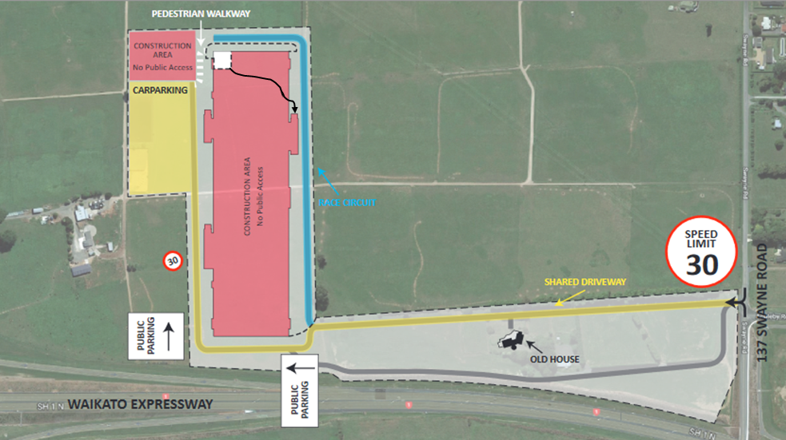
ELIGIBILITY
All riders must be of NZL nationality.
U19 Category is for riders aged between 17 and 18 as at 31 December 2021
U23 Category is for riders aged between 19 and 22 as at 31 December 2021
Elite Category is for riders aged 23 to 34 as at 31 December 2021
Riders older than 34 can opt to relinquish their Masters status for the entire 2021 licence year and then be eligible to compete in the Elite races. Contact events@cyclingnewzealand.nz for further information.

LICENCES
Every participant involved with the event needs to hold a 2021 Cycling New Zealand Licence. Click here to renew your licence. Riders and support personnel (managers, mechanics, drivers etc.) must have their valid 2021 licence card with them, or have it readily available, at all times during the Championships (including presentation at the Confirmation of Starters via the team manager). If the licence is still being processed, a receipt from Cycling New Zealand, along with a form of photographic identification (e.g., drivers licence) must be brought to the race.

ANTI DOPING
Drug Free Sport New Zealand may be in attendance at this event. Riders must ensure they have a photo ID available at all times if requested. Therapeutic Use Exemptions (TUE’s) must be available ready to be presented to the Doping Control Office.

RACE NUMBERS/ TIMING TRANSPONDERS
Each rider will receive two copies of a race number to be worn during the events and a frame number.
Each rider will receive one timing transponder to use for both events. This must be attached to your fork. Timing transponders must be returned after your race (if you are only competing in the Time Trial please return this on Friday after your race). There is a fee of $150+GST for any timing transponder not returned.
ROAD RACE SIGN-ON PROCEDURE
Each rider is required to sign the signature sheet, which will be available 1 hour and 10 minutes before the race start, and close 10 minutes prior to race start. The signature sheet will be on the stage near the start/finish on each road race day.
Sanctions will be imposed for any rider failing to sign on; a start may be refused.
WITHDRAWALS
Withdrawing prior to the race - There are no refunds available for any rider wishing to withdraw after entries close, however notification of your intention to withdrawn must still be received by the Commissaires Secretary by emailing events@cyclingnewzealand.nz or at the Confirmation of starters. Sanctions may be imposed if notification is not received. Withdrawing during a race – rider must advise the finish line Commissaire or other Commissaire as soon as possible and return their timing transponder to the event headquarters.
EVENT REGULATIONS
Racing will be conducted under UCI Regulations and Cycling New Zealand Road & Track Regulations.

Sanctions: The UCI scale of penalties will apply.
Any fines issued will be imposed on the Team or Centre and are invoiced by Cycling New Zealand post-event. The team manager or Centre is responsible for the payment.

EQUIPMENT
Bicycles must conform with current UCI and Cycling New Zealand Regulations.

Technical Checks will be conducted prior to the start of the Time Trial. Bicycles and equipment may also be checked at any other time, for both the Time Trial and the Road Race. The rider is responsible for ensuring all their equipment is in conformity with the Regulations.

All Under 19 races will be conducted on bicycles with a maximum roll-out of 7.93m. Checks will be conducted prior to the start for all riders, and after the race for medal placeholders.

RIDERS APPAREL
Riders must wear their approved Centre jerseys and shorts. Shorts may display sponsors that are detailed on the rider’s racing licence profile.
Only members of a 2021 UCI international trade team or 2021 NZ registered trade team, as detailed on the respective UCI or Cycling NZ websites, are permitted to wear their full approved team uniform.
A start may be refused for any incorrectly attired rider. Please contact events@cyclingnewzealand.nz with any questions regarding apparel.

TEAM VEHICLES

Team staff intending to follow a rider in the Time Trial, or Road Race, must register their vehicle by emailing events@cyclingnewzealand.nz prior to Friday 5th February. Please note that spaces in the convoy are limited and teams may be asked to share a vehicle.

Team Vehicle/Drivers briefings: All team car drivers registered to drive in the convoy for the road race must be present for a drivers meeting at the Race HQ on Taylor Street at the times below.
U19 Women’s Road Race: 12.15pm
U19 Men’s Road Race: 1.05pm
Elite/U23 Women’s Road Race: 7.15am
Elite/U23 Men’s Road Race: 9.30am
Time Trial – Teams are permitted to support any of their riders. The number of the rider being supported must be displayed in the car rear window. The TT rider’s second race number can be used for this purpose. Every car must have a flashing orange beacon, mounted on the left/passenger side of the car roof and must have UHF radio communication with the event (both to be supplied by Team / Centre). The radio channel to be used will be advised at the Managers Meeting.

Road Race – The President of the Commissaires Panel will determine which teams will be in the race convoy and preference will be given to those supporting multiple riders/teams. The team (or teams) name must be displayed in the car window. Every car must have a flashing orange beacon, mounted on the left/passenger) side of the car roof (to be supplied by Team / Centre). Every car must have a Radio which will be supplied by the event and allocated at the drivers meeting.

Please note – There is no feeding from the cars permitted in the U19 races. Team cars will be permitted to provide service only.

As per UCI reg 2.2.032 - Except in time trials, all the vehicles accompanying the race are restricted to a maximum height of 1.66 m (not including roof bars). Windows on the vehicle must not be obscured.

The team vehicles must be clearly identified and contain at least two occupants. The driver and mechanic (and anyone else who is required to get out of the vehicle onto the road) must be wearing a hi-viz vest. All people in the vehicle must hold a current Cycling New Zealand licence (Driver must also have a full NZ Drivers Licence).

Safe driving is essential when supporting riders. In particular, extreme care shall be exercised where there are gatherings of spectators and reduced speeds will apply when travelling through the start/finish area or feed zones. Posted speed limits may not be exceeded under any circumstances.

SPECTATORS
Parts of the race circuits are on narrow and some busy roads, so it is essential that spectator vehicle traffic is kept to an absolute minimum. If you do head to a viewing position on the circuit, ensure that you head out before racing commences and make sure your vehicles are parked well clear of the carriageway. Do not impend any business or residents in gaining access or departing their property. Be aware of the potential fire risk from hot exhausts on grass verges

ROAD RACE NEUTRAL SERVICES
Spare Wheels may be left at the Neutral Service vehicle area and must be placed there no later than 45 minutes prior to your event start time. Please ensure your race number is placed firmly on your wheels and identifying the speed of cassette, and if disc brake, if it a quick release or through axle type. Wheels can be picked up from the same location at the completion of your race. Note these Neutral Service wheels are provided for neutral support only and are not for specific individual use. Neutral technical support will be there for the whole race and will be used if no team car present. All teams and centres are expected to contribute wheels to neutral service.
MEDICAL

Medical Support will be present at each event venue for both days. Notify an event official in the case of medical attention being required.

The nearest medical centre is:
Cambridge Medical Centre - 48 Alpha Street, Cambridge, (07) 827 7184
The nearest 24 hour emergency clinic is:
Anglesea Clinic - Thackeray St, Hamilton, (07) 858 0800

The nearest hospital is:
Waikato Hospital - Pembroke Street, Hamilton, (07) 839 8899
In an Emergency call 111

MEDAL CEREMONY PROTOCOL
All riders shall, in accordance with their placing, participate in official ceremonies. Riders must wear their official racing attire. Street shoes will be permitted (no sandals, scuffs, Crocs or jandals). No sunglasses or caps etc to be worn on the podium. Medal winners are required to wear their medals around their necks until they have moved away from the podium area and any official media photography/filmed interviews are completed.
- Riders will be lead to the podium by officials and the riders will stand in front of the podium (not on podium).
- Each rider will be acknowledged by name and representing Centre/Team.
- Riders receive their medal.
- Rider step onto podium.
- Once the 1st place has been presented (National Champion jersey then medal) and stepped onto the podium a photo will be taken.
- Riders leave the podium and return to the waiting area lead by officials.
- All trophies presented are to be returned to Event Organisers before the end of the event.

See table below for Presentation Schedule. Presentation times are approximate but will be held as soon as possible after each race/set of races

Day/Time | Event | Presentation
Friday
1.30pm* | 2021 Vantage Elite, U23 & U19 Time Trial National Championships | All grades
Saturday
5.00pm* | 2021 Vantage U19 Road Race National Championships | U19 Women & Men
Sunday
11.30am* | Emerging Talent Award | Elite Women
 | Junior Road Ride of the Year Award | Junior Women
 | Elite Road Rider of the Year Award | Elite Women
 | 2021 Vantage Elite & U23 Road Race National Championships | U23 & Elite Women
2.30pm* | Emerging Talent Award | Elite Men
 | Junior Road Ride of the Year Award | Junior Men
 | Elite Road Rider of the Year Award | Elite Men
 | 2021 Vantage Elite & U23 Road Race National Championships | U23 & Elite Men

NATIONAL CHAMPIONS TITLE AND JERSEYS
Time Trial
All results are submitted to the UCI as separate races, with riders receiving UCI allocated points based on their race classification in each category.
There will be national jerseys awarded to the first placed U19, U23 and Elite rider in the Time Trial. Top 3 medals will be presented to all three categories in each gender.
Road Race
As the Elite & U23 Road Race events are combined, results are submitted to the UCI as one race, with riders receiving UCI allocated points based on their race classification in each race.
There is only one NZ National Champion (men and women), the winner of the combined race.
If an Elite rider wins the combined race, they will be awarded the NZ National Champions jersey, and the first placed U23 is awarded a NZ U23 Champion Jersey, which they may only wear at U23-only events.
If an U23 rider wins the combined race, they will be awarded the NZ National Champions jersey. The first placed Elite rider does NOT receive a Jersey. Top 3 medals will be presented to both categories.

The U19 race results are submitted to the UCI separately. The U19 winner will be awarded a national jersey (first place in the men’s and women’s race)

RESPECT FOR THE ENVIRONMENT

Waste Zones will be established before and after Feeding Zones. All riders must deposit their waste and empty bidons either at those locations, or to their team vehicles/neutral service.

No waste of any description is to be discarded from vehicles.
Please note: Sanctions can be imposed on breaches of this regulation. The penalty is applied to the team if the licence holder cannot be specifically identified

During training please ensure that you discard no rubbish.
GENERAL

We do also ask that whether you are racing, training or just riding back to accommodation, that you show other road users and residents’ courtesy, adhere to all road rules, and respect the environment.

If you have any questions about the championships or the procedures and rules we will be following, we would encourage you to contact the President of the Commissaires Panel (Technical matters) or the Event Manager well prior to your arrival in Cambridge.
SOCIAL MEDIA

We encourage you to get involved in the event through social media. The key links are provided below:
Event Facebook | https://www.facebook.com/CyclingNZL
Instagram | https://www.instagram.com/cyclingnewzealand
Twitter | https://twitter.com/CyclingNZL
Website | https://www.eliteroadnationals.nz
Key Partners | @VantageWindowsNZ
 | @ridenz.bike
Event Hashtag | #eliteroads

TIME TRIAL INFORMATION
Location: Roto-O-Rangi School, Kairangi Rd. Cambridge
Date: Friday 12 February 2021
Start Time: The first rider will start at 10.00am. Riders will start at 1 minute intervals and there will be a gap between the various grades. Start times will be published after entries close.
The Roads are OPEN. There is Traffic Management in place at key intersections however the roads are OPEN and riders should expect and anticipate public and officials vehicles on the course at all times in both directions. Riders will be required to stay on the left of the road and as far left as responsibly practicable. At all intersections you must take the correct side of any cones.
Age Category | Distance | Start Time
U19 Women | 18.4km | 10.00am
U23 Women | 27.6km
Elite Women | 27.6km
U19 Men | 27.6km
U23 Men | 44.2km
Elite Men | 44.2km
Race numbers: One required, centrally placed on the lower back. NO frame number required. 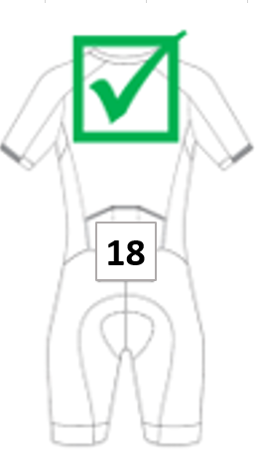
Technical checks: Riders are to present ready to start to the start area with their bicycle 10 minutes prior to their start time for final technical checks, otherwise a start may be refused. A Technical Check area will be open approximately 1 hour prior to the first rider starting, for riders wishing to have a pre-check carried out. Note that Race checks will take priority over pre checks.
Rollouts: All riders competing in U19 TT will be checked to ensure a bicycle maximum rollout of 7.93m.
Start line: Riders will be held in the start box but not restrained. Accordingly, riders who break the start will incur a time penalty. A start ramp will be used.
On the course: Only riders who are in competition are to be on the time trial course. Warm ups are not permitted on the course. Only riders who are in competition are to be on the time trial course. Warm-ups are not permitted on the course. Warm up area for rollers and stationary trainers will be within the car parking area, this is the preferred method of warmup due to the nature of the time trial course. Limited on road opportunity for warmup will be available, with times and locations to be notified at the managers meeting.

Hot seat: A Leading riders’ hot seat will be located at the finish line for the leading rider throughout the day. Please note it is compulsory for all leading rider in each category to sit in this chair when directed.
Medal Presentations: Medal presentations will take place for all categories at the conclusion of the Elite Men’s race.

Time Trial Start/Finish Map

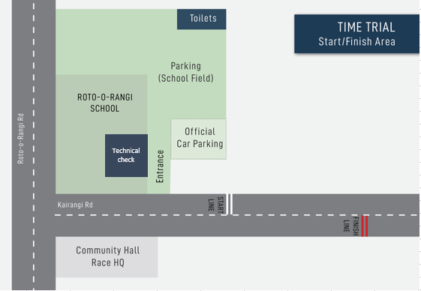

Time Trial Course Descriptions:
Under 19 Women
START - School onto Kairangi Road
ONE LANE BRIDGE
1.8km VEER LEFT onto Norwegian Road
5.7km TURN LEFT onto Roto o Rangi Road
9.1km U-TURN at Roto o Rangi Road / Kairangi Rd
12.6km TURN RIGHT onto Norwegian Road
16.6km VEER RIGHT on Kairangi Road
ONE LANE BRIDGE
18.3km Finish at school
Elite / U23 Women and U19 Men
START - School onto Kairangi Road
ONE LANE BRIDGE
1.8km VEER LEFT onto Norwegian Road
5.7km TURN LEFT onto Roto o Rangi Road
13.8km U-TURN at Roto O Rangi / Parklands Road
21.8km TURN RIGHT onto Norwegian Road
25.8km VEER RIGHT onto Kairangi Road
ONE LANE BRIDGE
27.6km Finish at school.
Elite Men
START - School onto Kairangi Road
ONE LANE BRIDGE
1.8km VEER LEFT onto Norwegian Road
5.7km TURN LEFT onto Roto o Rangi Road
13.8km TURN LEFT onto Parklands Road
18.2km TURN RIGHT onto Puahue Road
24.8km TURN RIGHT onto Long Road
27.3km TURN RIGHT onto Chamberlain Road
30.3km becomes Roto o Rangi Road
38.4km TURN RIGHT onto Norwegian Road
42.3km VEER RIGHT onto Kairangi Road
42.8km Proceed onto Kairangi Road
ONE LANE BRIDGE
44.2km Finish at School

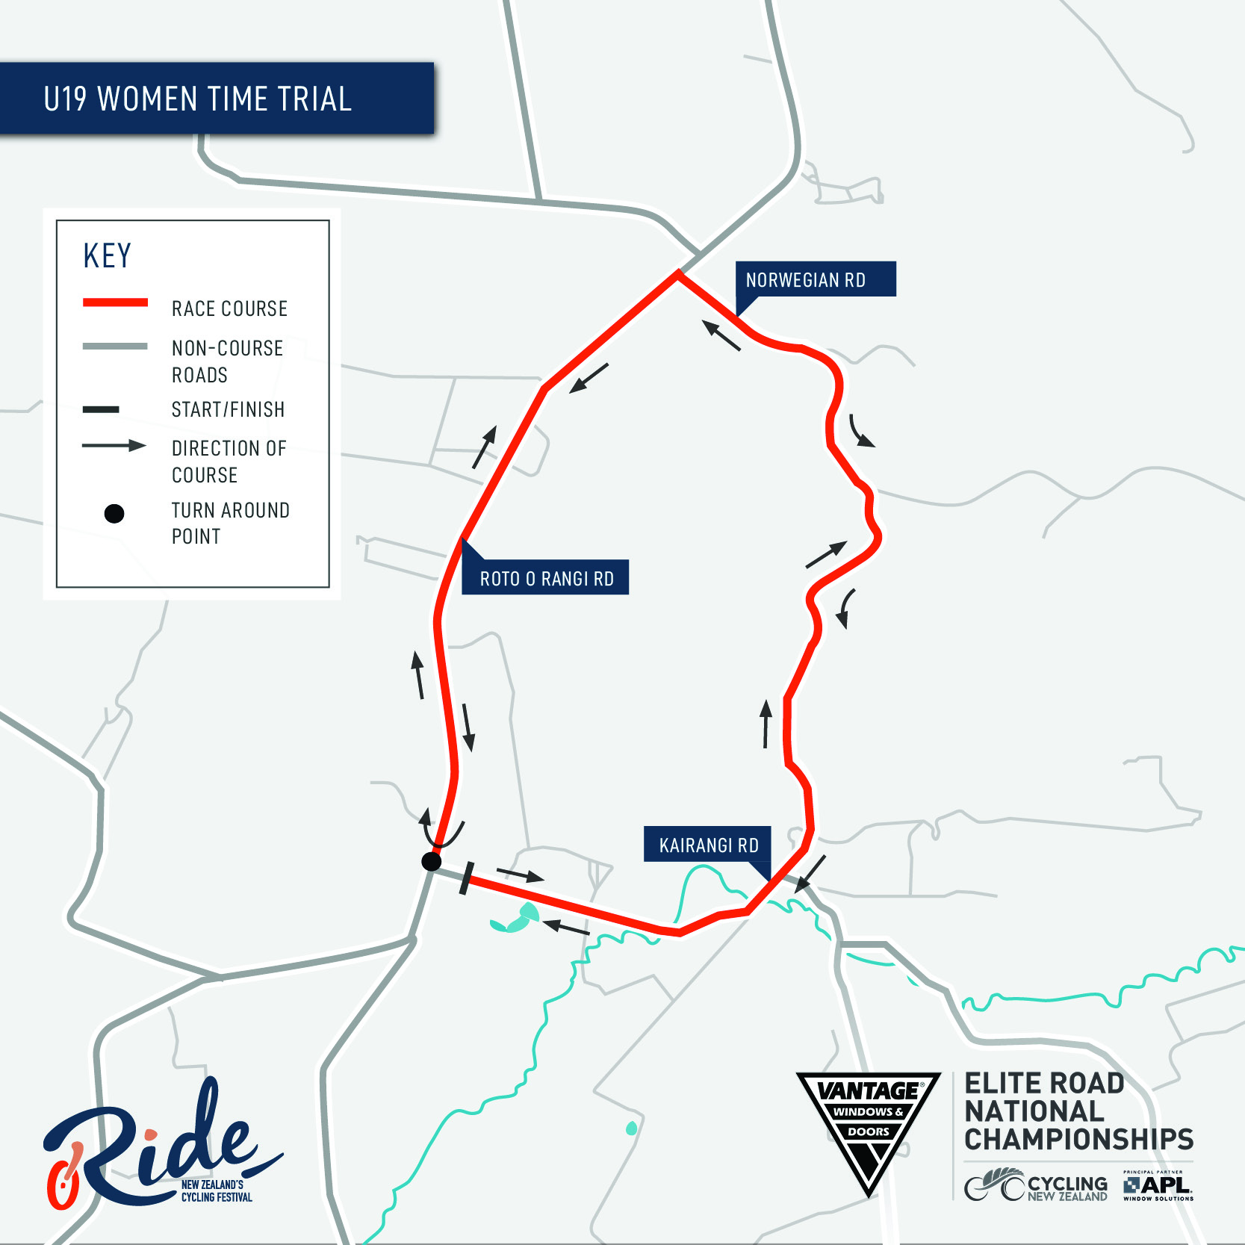

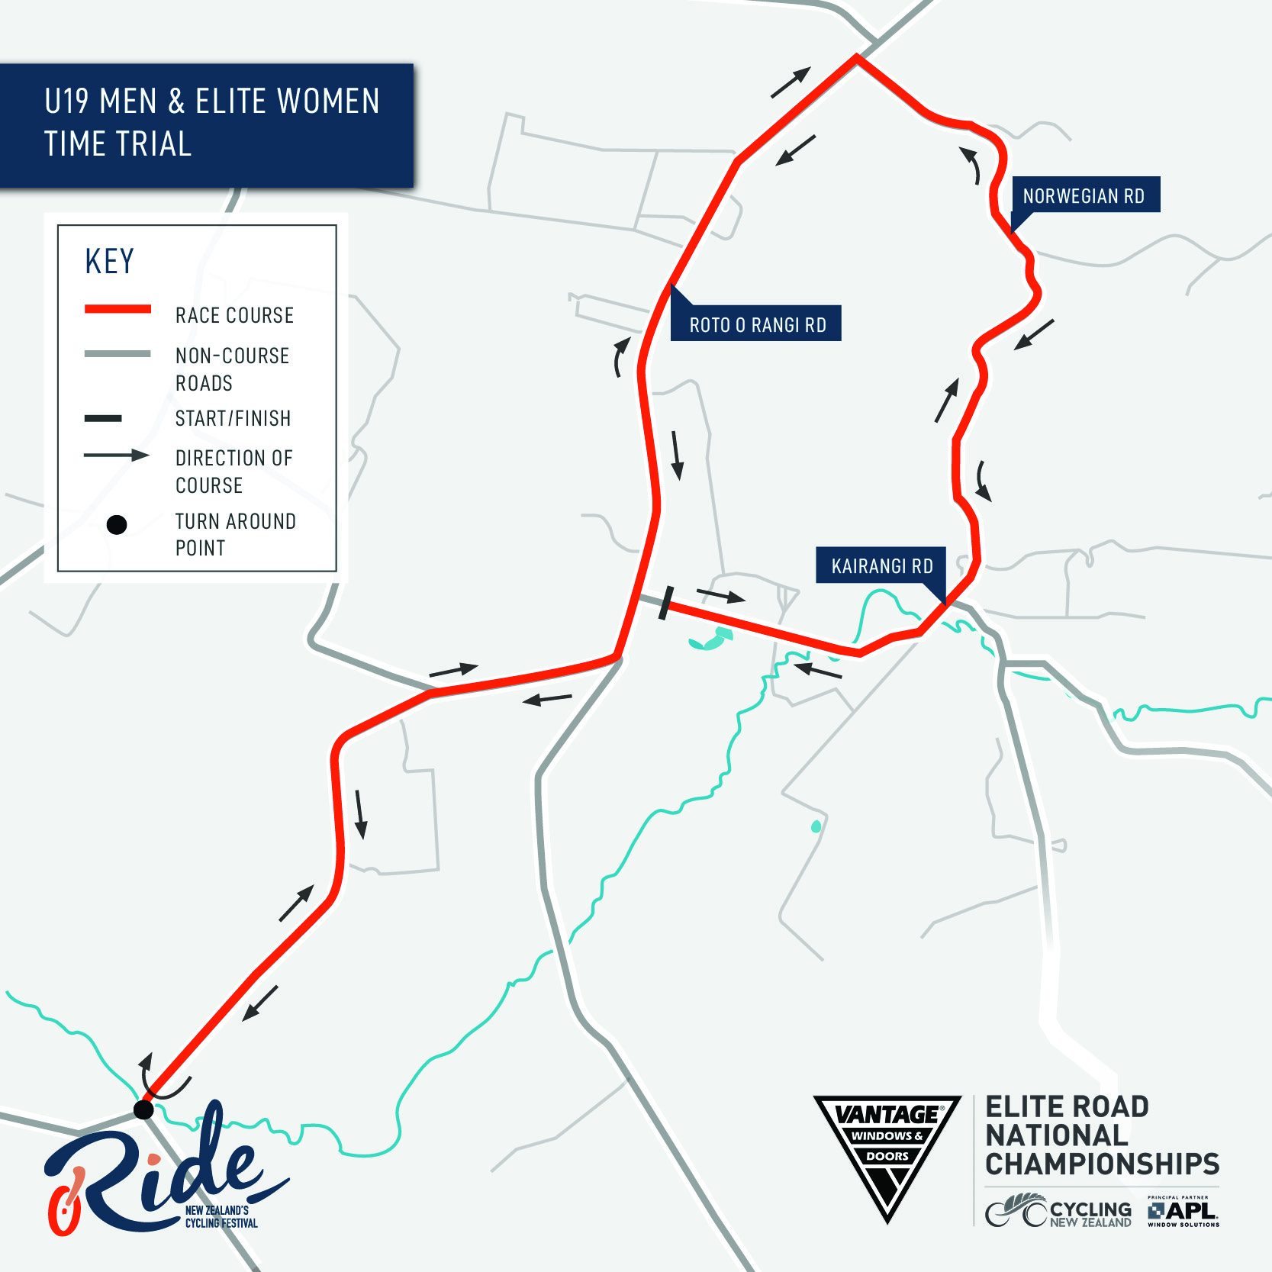

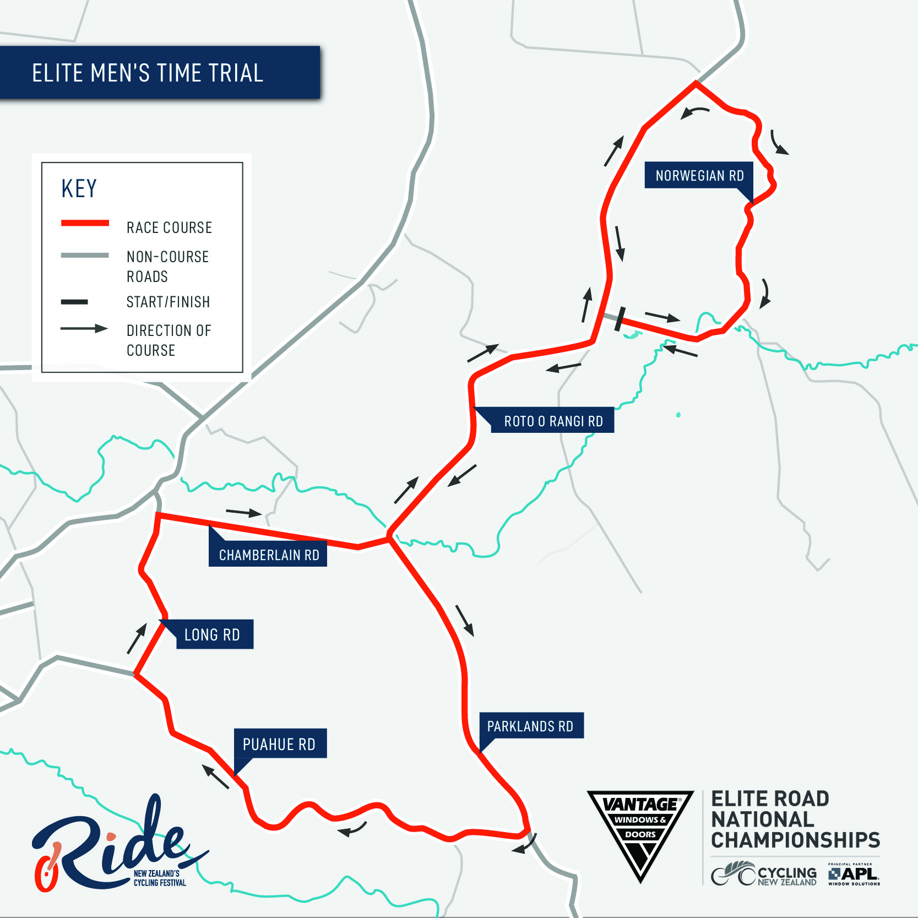

ROAD RACE - INFORMATION
Location: Tom Voyle Park, Taylor Street, Cambridge
Date: Saturday 13th & Sunday 14th February 2021
U19 Race: The Roads are OPEN. There is Traffic Management in place at key intersections however the roads are OPEN and riders should expect and anticipate public and officials vehicles on the course at all times in both directions. Riders will be required to stay on the left side of the road and as far left as responsibly practical and at all intersections you must take the correct side of any cones or centre lines.
Elite & U23 Race: The Roads are OPEN. There is Traffic Management in place to support a rolling block* however the roads should be considered OPEN and riders should expect and anticipate public and officials vehicles on the course at all times in both directions and make responsible decisions and stay on the left hand side of the road.
*A ‘rolling block’ is where there is additional traffic management to actively manage oncoming traffic however riders and drivers in the convoy should be aware that at any time there may still be cars on the course and they should keep to the left.
Age Category | Distance | Start Time
Saturday 13th
U19 Women | 80km | 1.00pm
U19 Men | 115km | 1.50pm
Sunday 14th
U23 Women | 130km | 8.00am
Elite Women | 130km | 8.00am
U23 Men | 174km | 10.15am
Elite Men | 174km | 10.15am
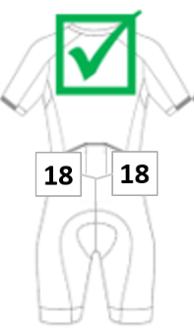
Race Numbers: Two numbers must be worn on the jersey, on the lower pocket area, with a hand width separation. Frame numbers are to be affixed behind the seat post. Numbers are not to be altered or folded in any way.

Team Vehicle Support: Refer to Team Vehicle Section.
Rollouts: All riders competing in U19 races will be checked to ensure a bicycle maximum rollout of 7.93m before the start, and placegetters after the race finish. Confirmation of the race result will only be given after these technical checks. Rollout will be conducted in the vicinity of the wheel drop adjacent to the finish line area.
Neutral service: Wheels will be required from teams to support the races. Please identify your wheels with the riders’ number on cardboard and give these to the neutral wheel vehicles well before the race start. Officials will aim to get the correct wheel to a rider, but no guarantee can be given. Priority for service will be to those riders in medal contention. In all cases, service will be on the left side of the road only and riders must be stationary.

On the course: Only riders who are in competition are to be on the race circuit. Supporters and any unauthorised vehicles are not to follow riders or interfere with the official race convoy.
Feed zones:
Feeding will only be conducted from the designated feed zone by team managers and their accredited assistants on the laps specified at the Managers Meeting.
1. 27km from the start at Te Miro School – this zone is for all races.
2. Just after finish line on Taylor Street, this is for Elite & U23 Men and Women’s races only.
3. The end of Maungakawa Road and start of Thornton Road, this is for U19 Men and Women’s races only.
See feed zone maps.
Feeding will be conducted in accordance with UCI rules 2.3.025, 2.3.026 and 2.3.027

Road Race Start/Finish Map
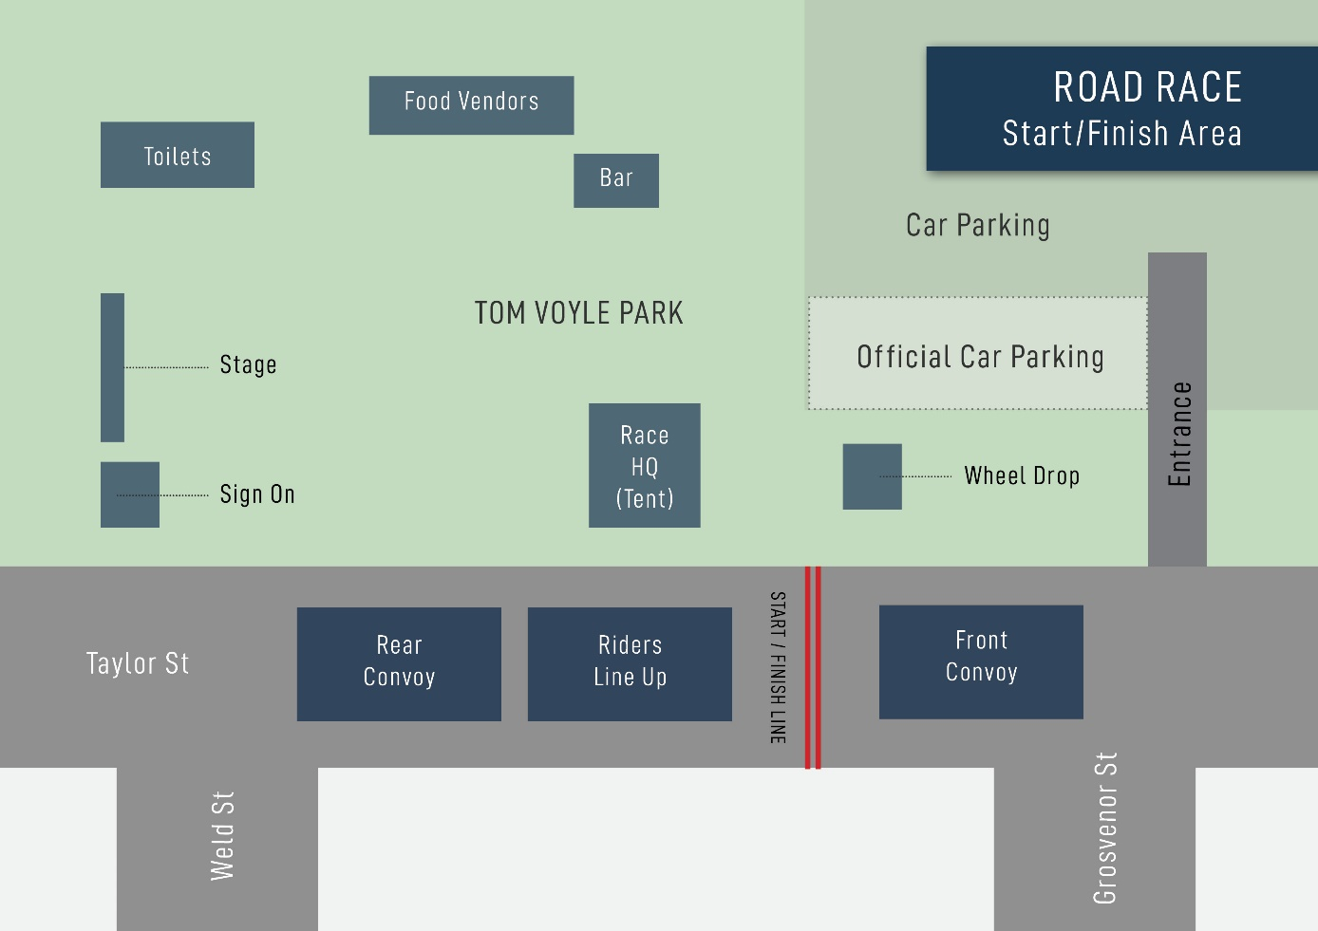

Road Race Course Descriptions:
Elite Women and Men
Start Race HQ on Taylor St.
Proceed onto Taylor Street
Swayne /Bowen intersection
Watkins /Robinson intersection
1.0km Continue on MacLean Street
1.6km TURN LEFT onto Thornton Road
3.3km veer right now on French Pass Road
"GULLY" / sharp corner
12.0km TURN LEFT onto Brunskill Road
20.9km TURN RIGHT onto Te Miro Road
pass Te Miro School (Feed Zone 1)
30.8km VEER LEFT onto Aspin Road
36.8km TURN RIGHT onto Fencourt Road
37.3km TURN LEFT onto Wells Place
38.1km TURN RIGHT onto Zig Zag Road
39.7km TURN LEFT onto Swayne Road
41.4km TURN RIGHT onto Norfolk Drive
42.4km TURN LEFT onto Victoria Street
43.0km TURN LEFT onto Taylor Street
(Feed Zone 2)
Road Closed Victoria Rd to Swayne Rd
43.6km Arrive at Finish LAP 1.
87.2km 2 Laps
130.8km 3 Laps Women’s Race Finish
174.4km 4 laps Men’s Race Finish

U19 Women
START - Race HQ on Taylor Street
cross over Swayne /Bowen intersection
cross over Watkins / Robinson intersection
1.0km becomes MacLean Street
1.6km TURN LEFT onto Thornton Road
3.3km VEER RIGHT now French Pass Road
"THE GULLY"
12.0km TURN LEFT onto Brunskill Road
"One Lane Bridge"
20.9km TURN RIGHT onto Te Miro Road
30.8km VEER LEFT into Aspin Road
36.8km TURN LEFT info Fencourt Rd - END OF LAP 1.
38.0km TURN RIGHT onto Maungakawa Road
39.5km TURN LEFT onto French Pass Road – now starting Lap 2.
"THE GULLY"
TURN LEFT onto Brunskill Road
"One Lane Bridge"
TURN RIGHT onto Te Miro Road
VEER LEFT into Aspin Road
73.4km TURN RIGHT onto Fencourt Road - END OF LAP 2 - head back to finish
73.9km TURN LEFT into Wells Place
74.7km TURN RIGHT into ZigZag Road
76.3km TURN LEFT into Swayne Road
78.0km TURN RIGHT into Norfolk Drive
79.0km TURN LEFT into Victoria Road
79.7km TURN LEFT into Taylor St
80km Finish - Taylor St / Tom Voyle Park

U19 Men
START - Race HQ on Taylor Street
cross over Swayne /Bowen intersection
cross over Watkins / Robinson intersection
1.0km becomes MacLean Street
1.6km TURN LEFT onto Thornton Road
3.3km VEER RIGHT now French Pass Road
"THE GULLY"
12.0km TURN LEFT onto Brunskill Road
"One Lane Bridge"
20.9km TURN RIGHT onto Te Miro Road
30.8km VEER LEFT into Aspin Road
36.8km TURN LEFT info Fencourt Rd - END OF LAP 1.
38.0km TURN RIGHT onto Maungakawa Road
39.5km TURN LEFT onto French Pass Road – now starting Lap 2.
"THE GULLY"
TURN LEFT onto Brunskill Road
"One Lane Bridge"
TURN RIGHT onto Te Miro Road
VEER LEFT into Aspin Road
73.4km TURN RIGHT onto Fencourt Road - END OF LAP 2
Complete another full lap
109.6km TURN RIGHT onto Fencourt Road - END OF LAP 3 -now head back to the finish
110.1km TURN LEFT into Wells Place
110.9km TURN RIGHT into ZigZag Road
112.5km TURN LEFT into Swayne Road
114.2km TURN RIGHT into Norfolk Drive
115.2km TURN LEFT into Victoria Road
115.8km TURN LEFT into Taylor St
116.2km Finish - Taylor St / Tom Voyle Park

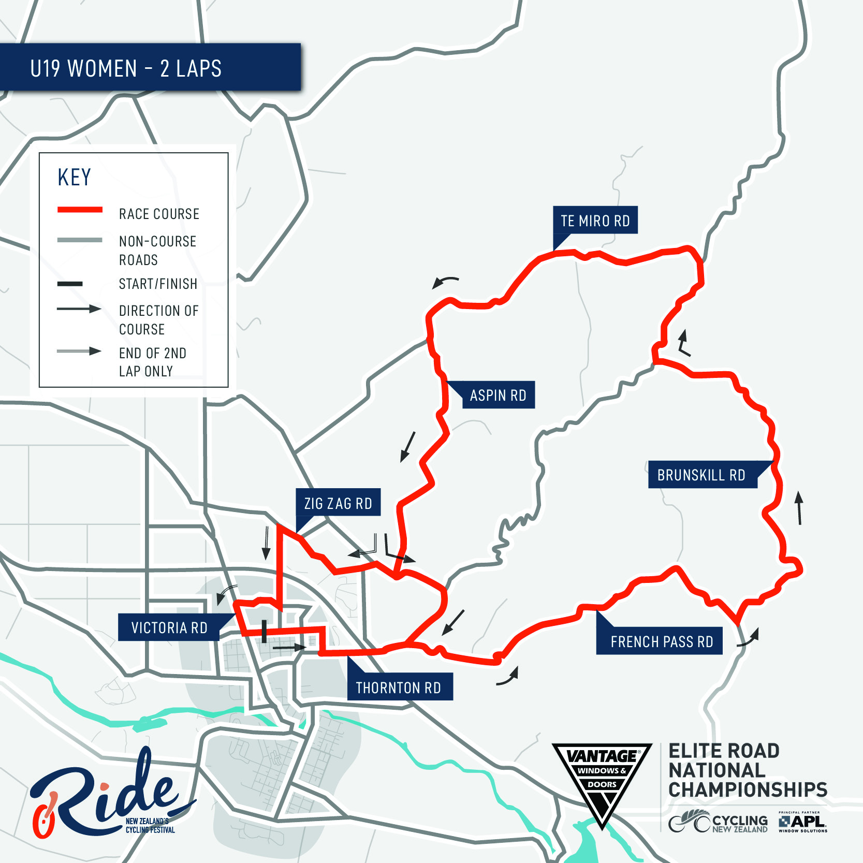

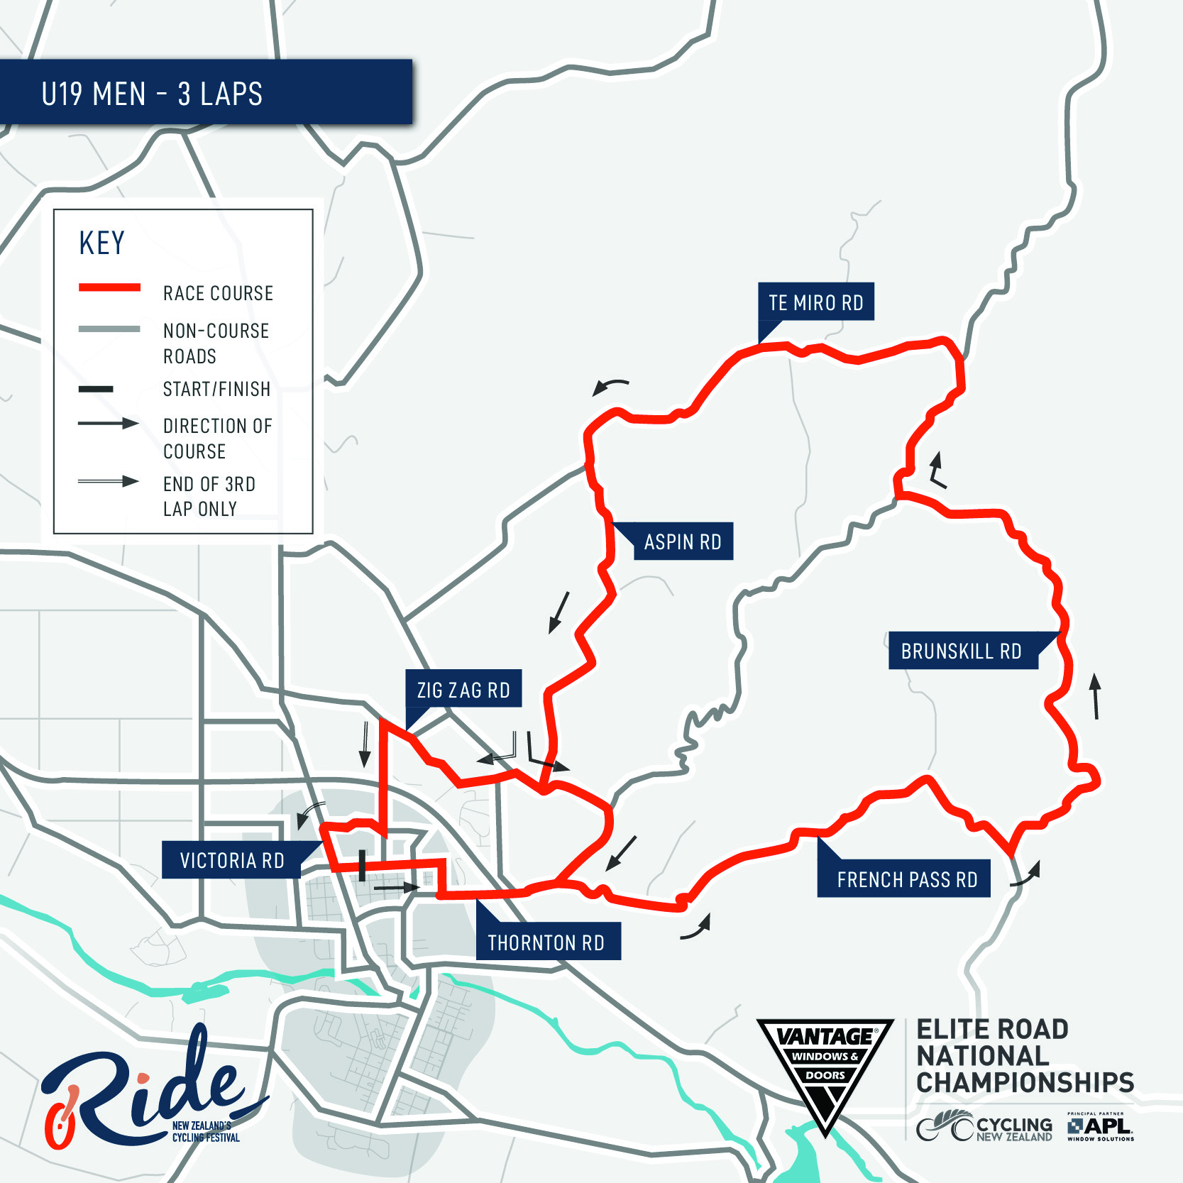

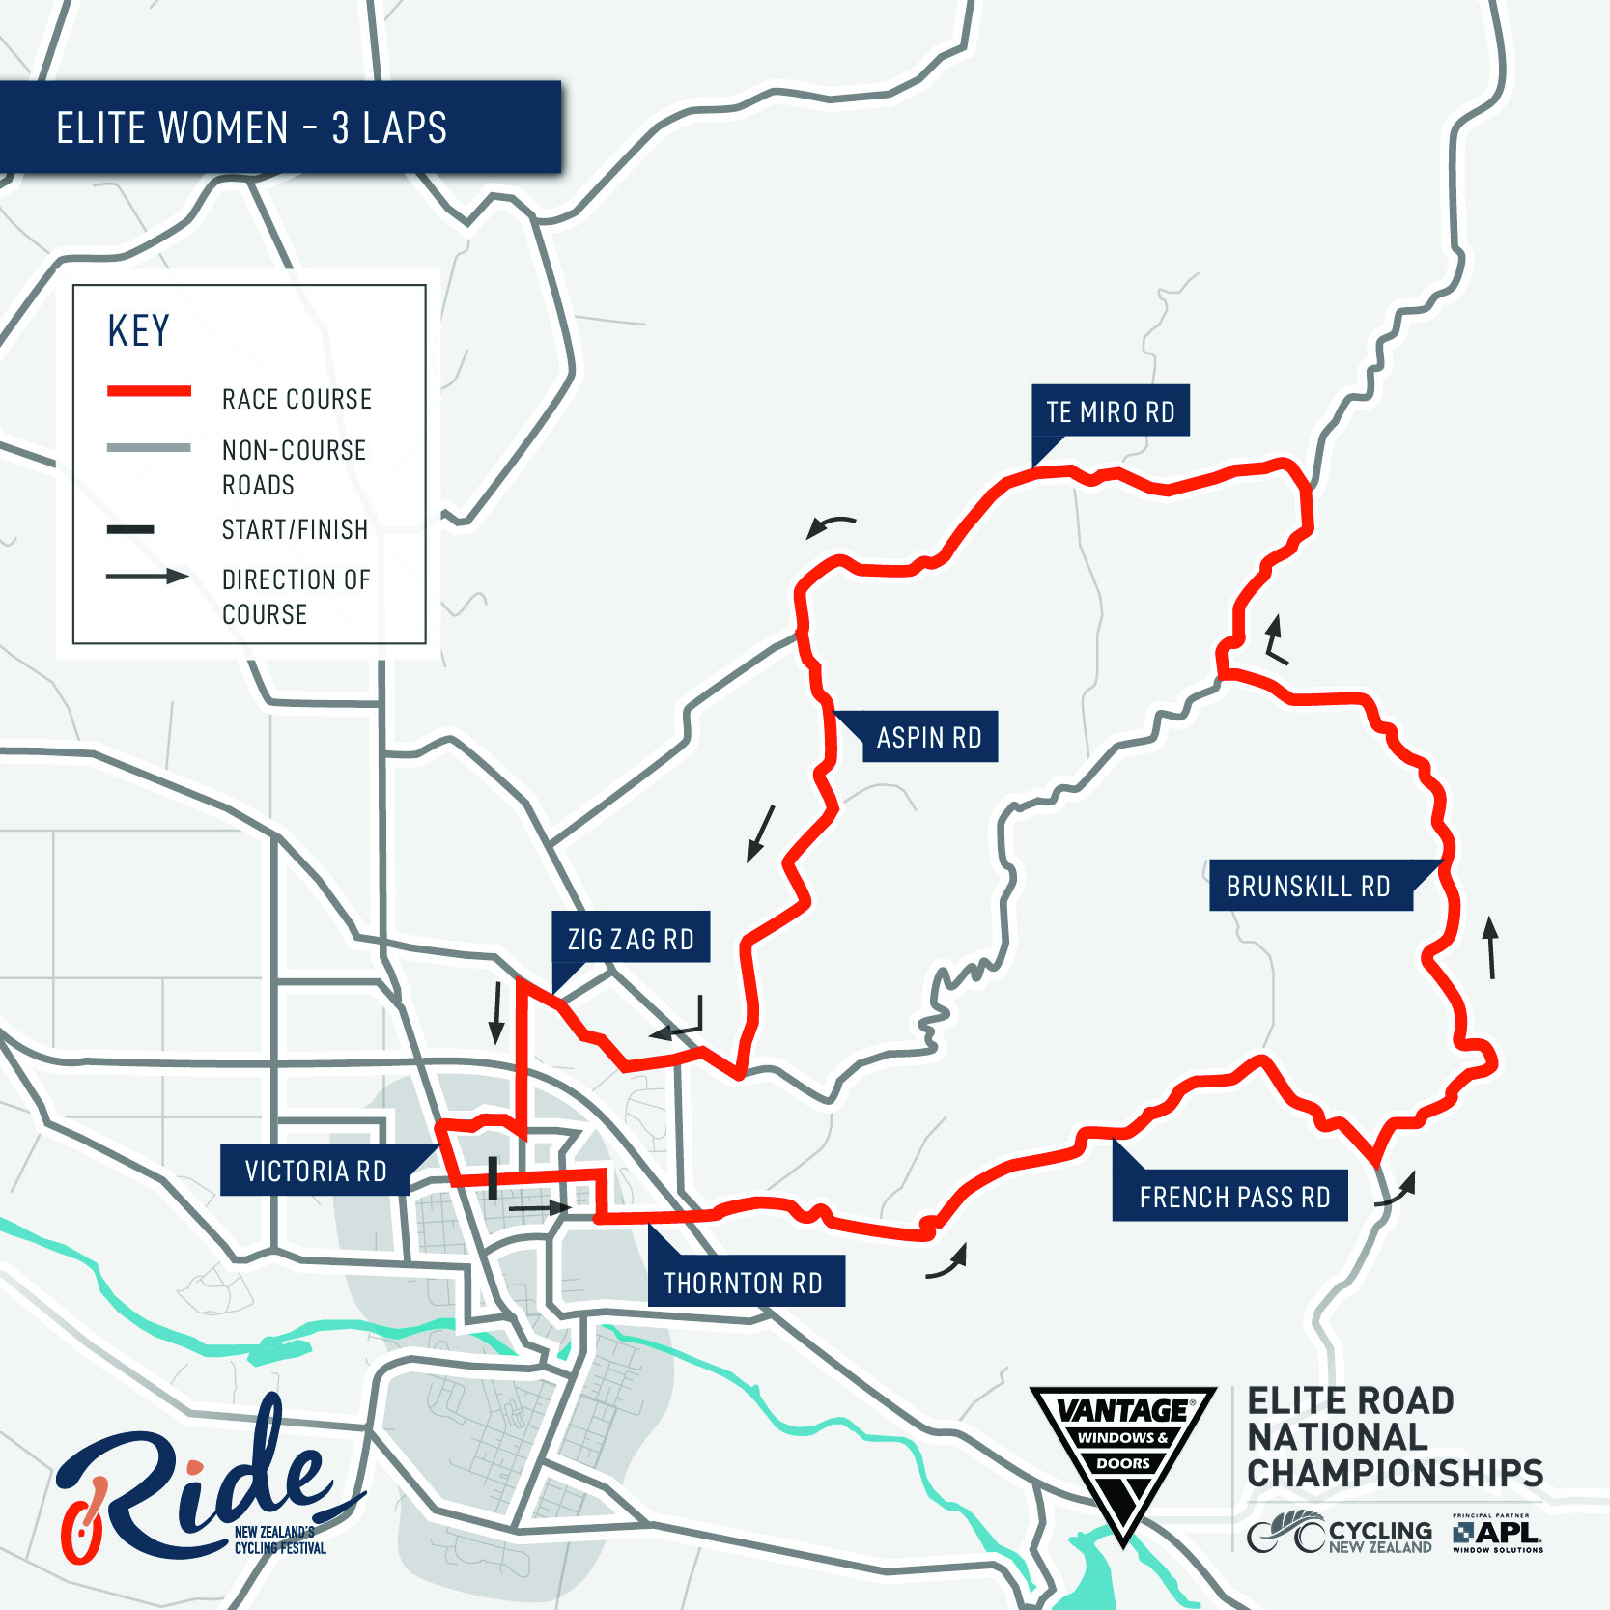

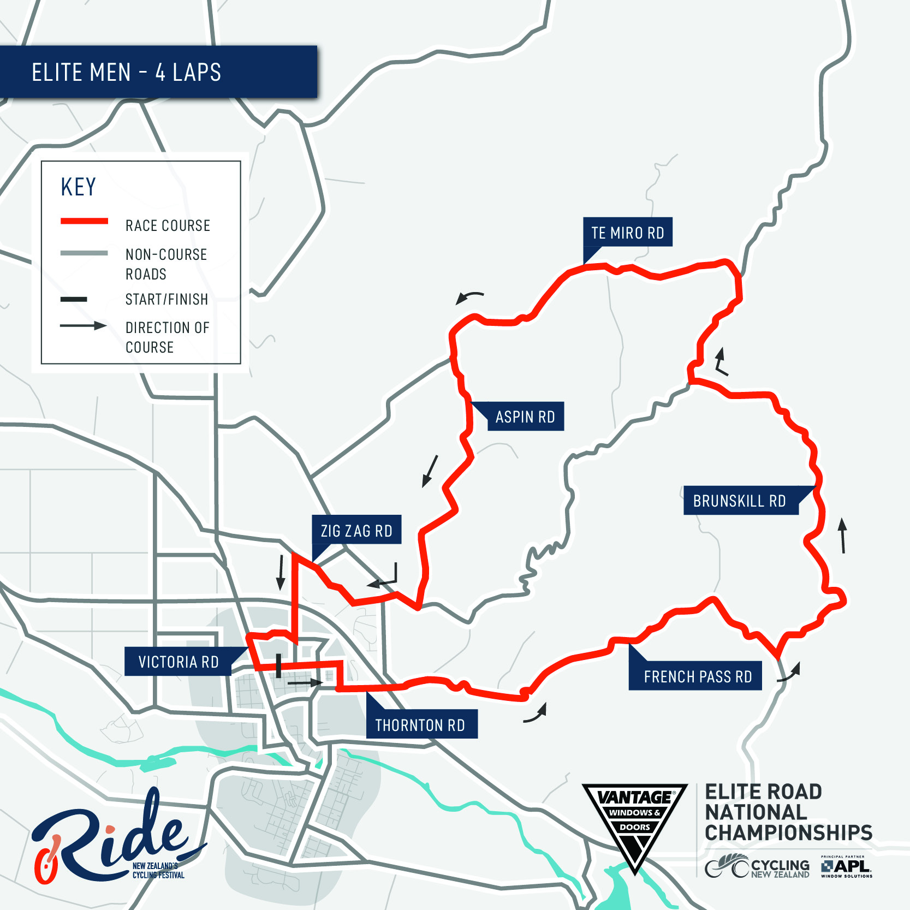

Road Race Convoy – Elite Women and Elite Men’s Races
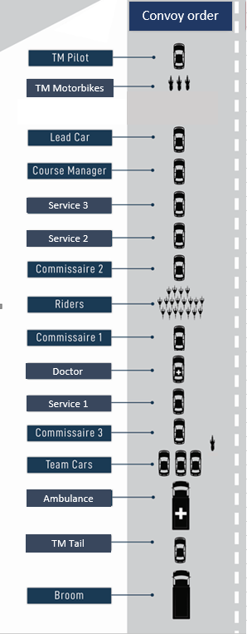
* Road Race Convoy order amendments will be confirmed at the Team Manager’s Meeting. U19 Convoy Information will be confirmed at the Team Manager’s Meeting.

COVID-19 RESPONSE
At the time of publication, host region, Waikato and the rest of New Zealand are currently in Alert Level 1.
We are monitoring this daily and will provide further updates if there are any changes that may impact the event including but not limited to a change in Alert Level status.
If you test positive for Covid-19 post the event please contact Cycling New Zealand immediately.
Golden Rules for Covid Alert Level 1
Please ensure that you and your supporters use the contact tracing available at the event and scan the event QR code.

- If you’re sick, stay home. Please do not turn up at the event.
- If you have cold or flu symptoms call your doctor or Healthline and make sure you get tested.
- Wash your hands. Wash your hands. Wash your hands.
- Sneeze and cough into your elbow, and regularly disinfect shared surfaces.
- If you are told by health authorities to self-isolate you must do so immediately.
- If you’re concerned about your wellbeing or have underlying health conditions, work with your GP to understand how best to stay healthy.
- Keep track of where you’ve been and who you’ve seen to help contact tracing if needed. Use the NZ COVID Tracer app as a handy way of doing this.
- It is still worthwhile to keep a safe distance from people you don’t know while out and about. This will help to minimize the spread of Covid-19 if community transmission returns.
- Continuing good habits with face coverings will keep you and others safe, even at Alert Level 1 when it’s no longer compulsory.
- People will have had different experiences over the last couple of months. Whatever you’re feeling — it’s okay. Be kind to others. Be kind to yourself.

