Appendix 2: How to upload or make your submission online

Click organisation button (your RSO / Club) and click that you would like to appear before the Committee. You don’t have to, but it will impress MPs much more if you do.  Appearances (known as hearings) will probably be held early September, during the working day, and usually by video. You will have five minutes to say one thing about the impact on your RSO / Club then answer questions. | 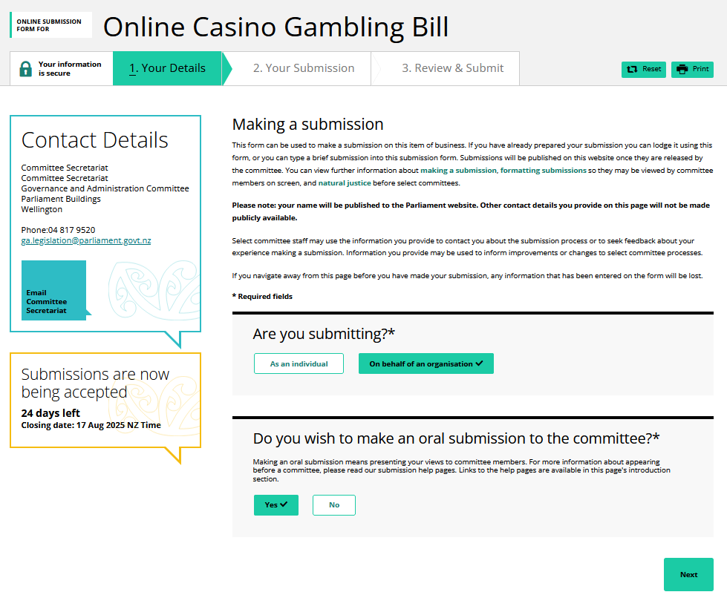
Fill out your details. Preference is for Chairs or role-holders in RSOs / Clubs. | 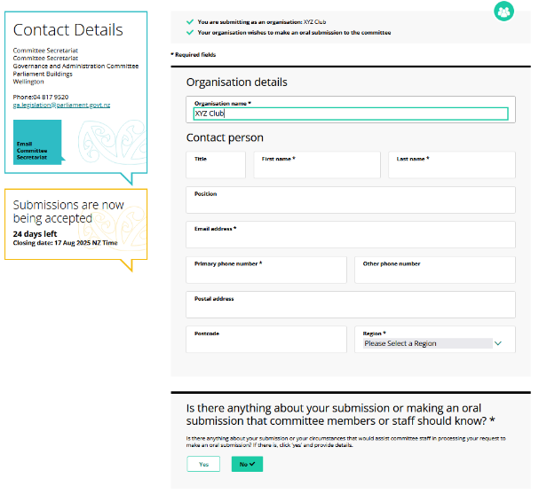
If you have a submission document, click upload submission. A box will help you choose and upload the document from your files. You will then be taken to the final page to confirm your details and complete the submission.  If you are using the online form, follow instructions below:  In the comments field box, insert content from “Summary” and “Main points” in the template submission above – making sure to replace our guiding sentences with your own words.  In the “recommendations” box copy this:  Embed in the Bill the same principle from the Gambling Act 2003 (and the 1977 Gaming and Lotteries Act before it); “Gambling should benefit the community.” Carry this out by requiring that some revenue from online casino gambling is shared with the community, especially sport. | 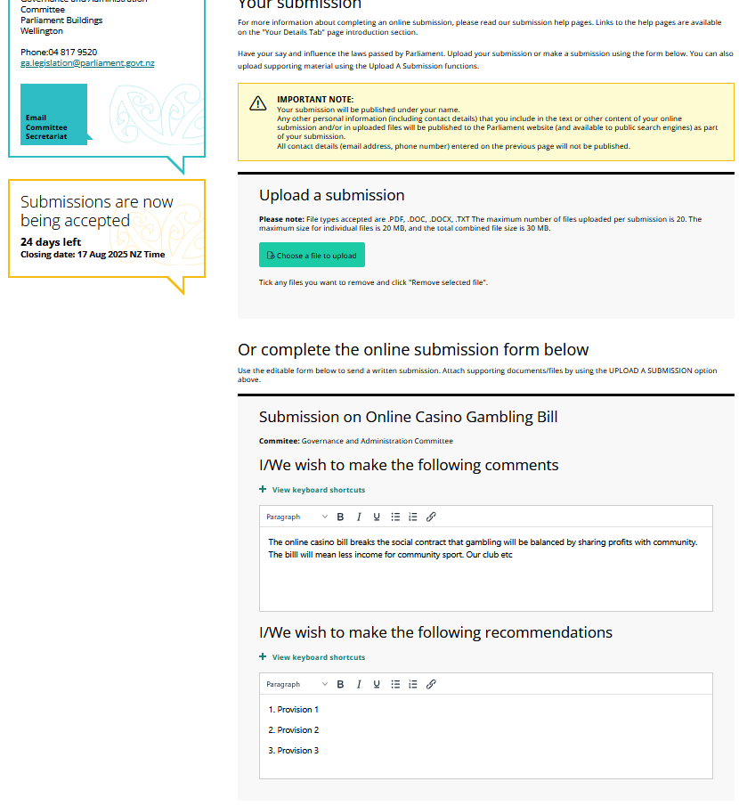
Review submission, tick Privacy Statement, and click Submit. | 



